Lab 2: Oracle DML Operations – Insert, Update, Select, Delete
Date: 02/11/2025
Database Lab
Objectives:
To be able to insert a new record in a parent table.
To be able to verify the records inserted.
To be able to verify domain constraints and referential integrity.
To be able to update and delete records.

Tools Used
Oracle Database XE
SQL Developer
Docker

1. INSERT Operations
General Syntax:
INSERT INTO table_name (column1, column2, ...)
VALUES (value1, value2, ...);
Example:
Insert records into parent and child tables.
Parent table: COURSES
INSERT INTO courses (course_id, course_name, instructor)
VALUES (101, 'Database Systems', 'Dr. Smith');

Child table: STUDENTS
INSERT INTO students (student_id, student_name, course_id)
VALUES (1, 'Alice Johnson', 101);

INSERT INTO students (student_id, student_name, course_id)
VALUES (2, 'Bob Williams', 101);

COMMIT;
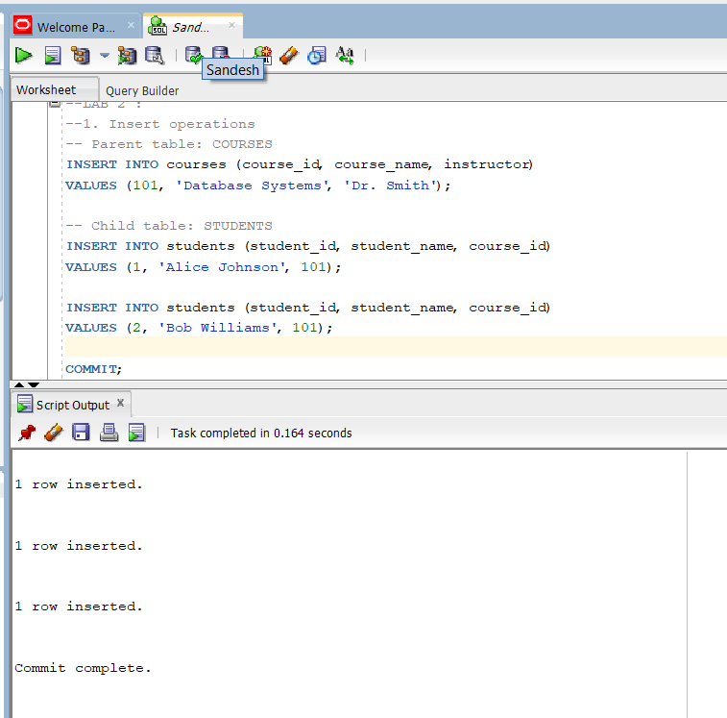

2. SELECT Operations (Verification)
General Syntax:
SELECT column1, column2, ...
FROM table_name
WHERE condition;
Example:
Verify that the records were inserted successfully.
Verify parent table
SELECT * FROM courses WHERE course_id = 101;
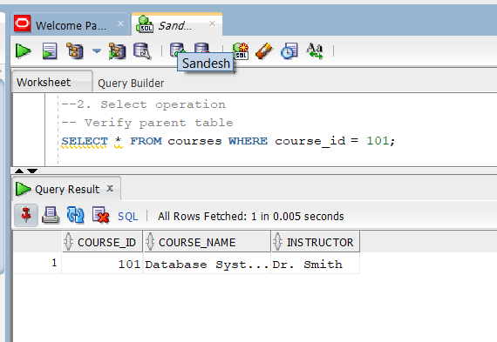

Verify child table
SELECT * FROM students WHERE course_id = 101;
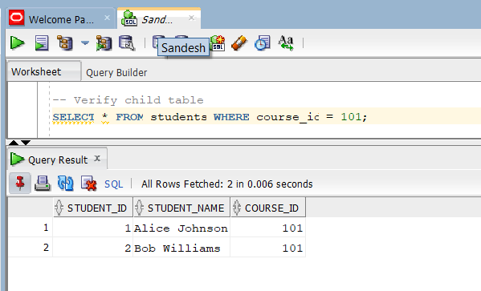

Verify parent-child relationship
SELECT s.student_id, s.student_name, c.course_name, c.instructor
FROM students s
JOIN courses c ON s.course_id = c.course_id;
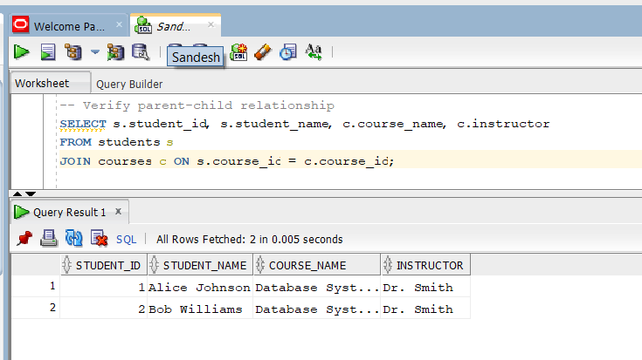

3. Constraint Verification
Domain Constraint Check:
Try inserting invalid data (violating NOT NULL constraint)
INSERT INTO courses (course_id, course_name, instructor)
VALUES (NULL, 'Invalid Course', 'Dr. John'); -- Should fail
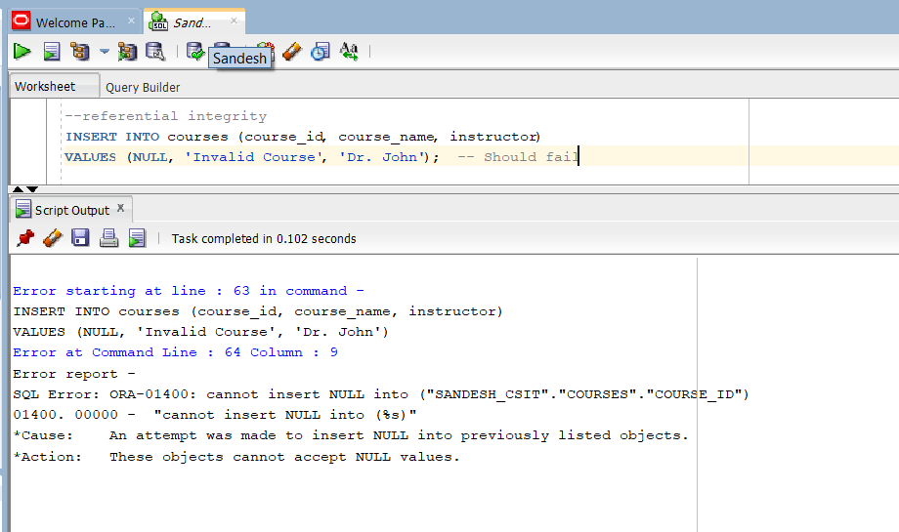
Referential Integrity Check:
Try inserting student in non-existent course
INSERT INTO students (student_id, student_name, course_id)
VALUES (3, 'Charlie Brown', 999); -- Should fail (no such course_id)
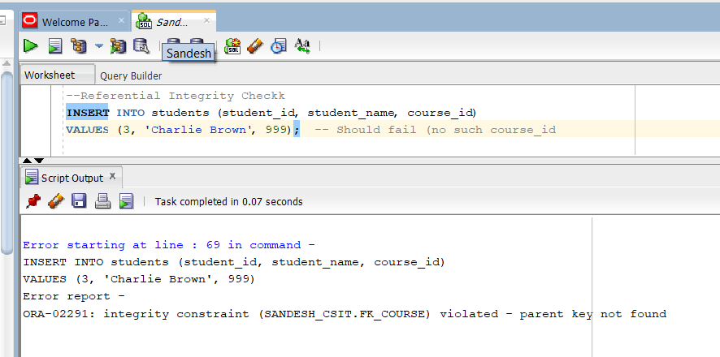

4. UPDATE Operations
General Syntax:
UPDATE table_name
SET column1 = new_value1, column2 = new_value2, ...
WHERE condition;
Example:
Update course instructor
UPDATE courses
SET instructor = 'Dr. Adams'
WHERE course_id = 101;
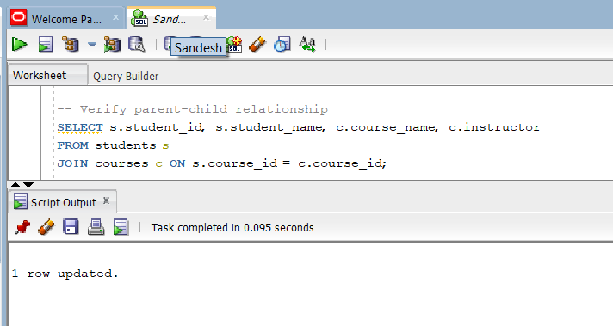

Update student name
UPDATE students
SET student_name = 'Alice Parker'
WHERE student_id = 1;

COMMIT;
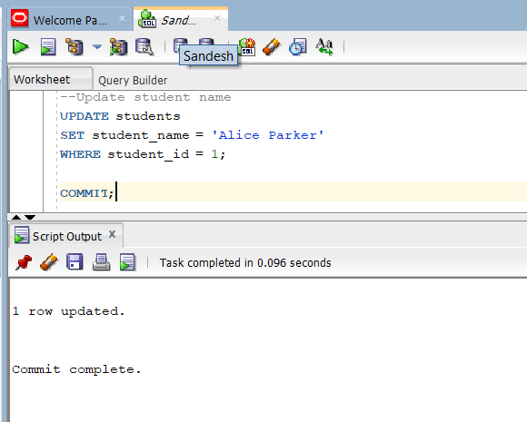

5. DELETE Operations
General Syntax:
DELETE FROM table_name
WHERE condition;
Example:
Delete child records first
DELETE FROM students
WHERE course_id = 101;
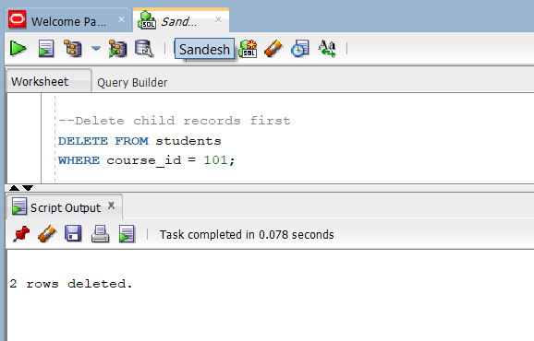

Then delete parent record
DELETE FROM courses
WHERE course_id = 101;

COMMIT;

Conclusion
In this lab, we practiced DML operations including inserting, updating, selecting, and deleting records in related tables (courses and students). We also verified domain constraints and referential integrity, ensuring that dependent records maintain consistency when performing modifications.

